**Year 10 Physics EXAM Name: ________________**

**Teacher:**

**Multiple Choice Answer Sheet Total = /43 marks**

1. A **B** C D 11. A **B** C D

2. A **B** C D 12. A B C **D**

3. A **B** C D 13. A B C **D**

4. **A** B C D 14. **A** B C D

5. A B **C** D 15. **A** B C D

6. A B **C** D 16. A **B** C D

7. A B **C** D 17. **A** B C D

8. A **B** C D 18. A **B** C D

9. A B **C** D

10. A **B** C D

**Short Answer: Name: _________________**

**Answer in the spaces provided 25 marks**

**1** **Classify the following as True or False:**  (6)

a A motorbike is accelerating away from traffic lights : this is INERTIA True **/ False**

b Work is the ability to exert force over a distance **True /** False

c Acceleration depends on mass and distance True **/ False**

d Velocity is a measure of Power True **/ False**

e The reason a ball bounces is because “energy is not

lost or created but is transformed” **True** / False

f Displacement has a measurement and a direction **True /** False

**2.** State Newton’s Third Law of Motion (1)

[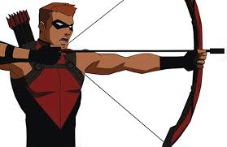](http://www.google.com.au/imgres?imgurl=http://www.writeups.org/img/inset/Red_Arrow_YJTV_h2.jpg&imgrefurl=http://www.writeups.org/fiche.php?id%3D5242&h=389&w=600&tbnid=8BHuG_mgtKVSDM:&docid=j9yOZ540PEWiyM&hl=en&ei=RwxUVpKSO6bFmAX0zKToDw&tbm=isch&ved=0ahUKEwjS0ZTDv6jJAhWmIqYKHXQmCf0QMwh9KFowWg)For every action there is an equal and opposite reaction

Describe what happens to the arrow and bow which shows Newton’s Third Law (2)

The arrow – Will fly forward propelled by the bow string

The bow – Will have a lesser force acting on it

**3.**  A student performs an experiment with some coins and a piece of paper

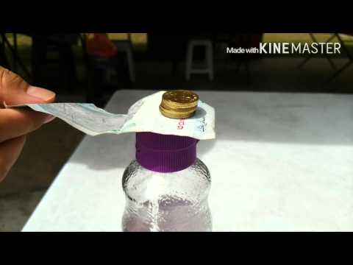

The paper is pulled quickly away – describe what happens to the coins. (2)

Stack of coins remain stacked and in same place when paper is moved

Which of Newton’s Laws explains this concept: (1)

First Law – of Inertia – An object at Rest will tend to remain at rest

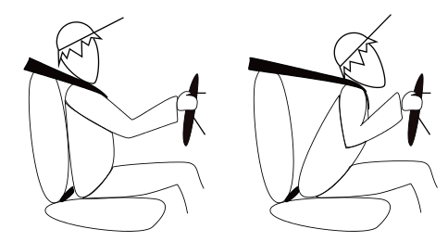

**4** Describe what happens in the picture above when car brakes suddenly: (2)

Person is still moving forward so they will push forward into the belt

Car is slowing rapidly and will try to pull person backward

**5** Calculate the WORK done : (2)

Kelly uses a force of 160 N to moves a BOX a distance of 5 metres

W = f x d

W = 160 x 5 = 5300 J

**6** A ball is dropping from 2.5 m the Kinetic energy is 2655 J the Potential energy is 3411 J.

Calculate the total energy (2)

Et = Ep + Ek

Et = 3411 + 2655 = 6066 J

**7** Fill in the following table (3)

|  |  |
| --- | --- |
|  | **Units** |
| Force | Newtons |
| Energy | Joules |
| Work | Joules |
| Speed | m/s |
| Acceleration | m/s2 |
| Kinetic Energy | Joules |

1. Adam runs a marathon, a 39 km long distance race. It takes him 4 hours.

What was his average velocity (speed)? (2)

V = d/t

V = 39/ 4 = 9 .75 km/ hr

1. What happens in each of these unbalanced forces? (2)

*Craig*  650N Andrew 200N

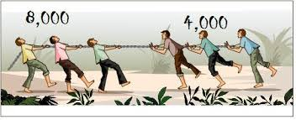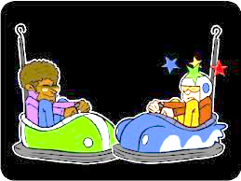Craig has greater force and will push

Andrew’s car backwards

The people on the left will

pull the group on right forward